Justin, Josh, Seth

9/30/18

CSC 440

Requirements Specification Report

Functional Requirements:

1. Create New Account
2. Logging in
3. Creating a new project
4. Uploading files
5. Downloading files
6. Logging out

Non-Functional Requirements:

1. At least 1 capital, 1 lowercase, 1 number, and at least 8 characters long when signing in
2. Comments on uploads
3. Security Questions when logging in
4. Time-stamp for upload
5. Search function
6. Listing project

Domain Requirements Specification:

R1 the user can create an account

R1.1 The user shall create an account by clicking the register button

R1.2 The user shall enter a username

R1.3 The user shall enter a password

R1.4 The user shall enter an email address

R1.5 The user shall enter a name

R1.6 The user shall click the create account button

R1.6.1 The system checks username availability

R1.6.2 The system shall display a string if the username has been taken or not

R1.6.3 The system shall return an error if the username has been taken and will send the user back to the same screen (R1.2)

R2 Log in to newly created account

R2.1 The user shall click the login button

R2.2 The user shall enter either their username or email address

R2.3 The user shall enter their password

R2.4 The user shall click the login button

R2.4.1 The system should check if this is account exists

R2.4.2 The system shall log the user in if it does

R2.4.3 The system shall return the user back to R2 with an error message if it

does not

R3 Creating a new project

R3.1 User shall click the new project button

R3.2 User shall name the project

R3.3 The user will choose the level of security that they want

R3.3.1 The system will give them the choice between public and private projects

R3.4 The user will then click the create project button

R4 Uploading files to Git

R4.1 User clicks on the project that they wish to change/update

R4.2 User shall upload their changes that they made to the project

R4.2.1 The system shall let the user know if they can access the project

R4.2.2 The system will allow the change to the project space to go through if they do have access

R4.2.3 The system will return an error if they don’t have access to the project

R4.3 The user shall be given the option to upload more changes they have to project

R4.4 The user shall be able to exit and work on other projects

R5 Downloading projects

R5.1 The user shall have the option to look at both past projects that they have made as well as others

R5.2 The user shall click on the download button if they wish to download the current project to their computer (R4.2.1 - R4.2.3 for permission)

R5.3 The user shall be able to work on the project

R6 Logging out of account

R6.1 The user shall click on their account icon

R6.1.1 The system will display a drop-down list of options for the user

R6.2 The user shall navigate to the logout button

R6.3 The user shall click the logout button to log out of their account

Use Case Diagram:

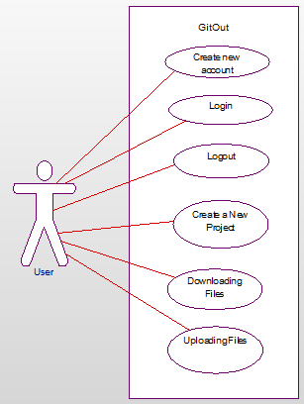

Domain Diagram:

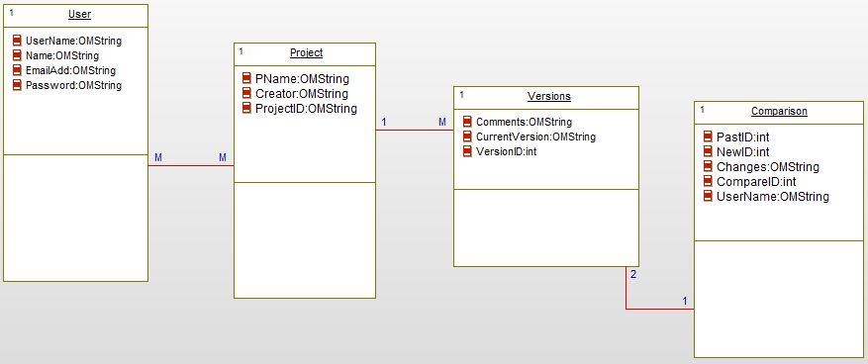

Data Dictionary:

|  |  |  |  |
| --- | --- | --- | --- |
| Field Name | Data Type | Field Length | Description |
| UserName | String | 20 | Name displayed for user |
| Name | String | 20 | Name of user |
| EmailAdd | String | 50 | Email address of user |
| Password | String | 15 | Password for user |
| PName | String | 20 | Name of created project |
| Creator | String | 20 | User that created the project |
| ProjectID | Int | 50 | ID given to the project |
| Comments | String | 100 | Descriptions of user interactions |
| CurrentVersion | String | 20 | Latest version of the project |
| VersionID | Int | 20 | ID of the version |
| PastID | Int | 20 | ID before the latest version |
| CurrentID | Int | 20 | ID of the current project |
| Changes | String | 50 | Changes that have occured in the project |
| CompareID | Int | 20 | ID of the comparison between the PastID and currentID |